CURTIN MAURITIUS

INTRODUCTION TO BUSINESS PROGRAMMING

SEMESTER 1 2022

ASSIGNMENT 2 REPORT WRITING

DATE OF SUBMISSION: 29TH MAY 2022

Name of student : Nikhil Hurreba

Student id: 20402327

Student email: [20402327@student.curtin.edu.au](mailto:20402327@student.curtin.edu.au)

Business report is an official document that is used by company head to track the state of the company in actual time. It contains statistics and researched information; these data contribute to have a future overview of the company and to increase handling of the business to avoid corruption and bankruptcy. The report might contain graphs, plots and python notebooks. (Calzon 2021). In this business report we will analyse the business efficiency and historical information of Enron from year 2000 as it went bankrupt due to a fraud despite being one of USA’s largest company. This report will analyse more on the email of Enron which turned the company to destruction.

In the first part of the business report, we will analyse and generate graphs **for number of messages each day by date:**

Python which will be used for reports of Enron first of all is a high-level programming language used in notebooks to have live equation and to write codes which will be called python coding.

Python notebooks and google collab will be used to generate the data of Enron company to get historical data of the company and here emails quantity must be analysed using graphs to be able to come to the end of this issue. The numbers of email sent will be represented on graph and plotting will be done to get more precise outputs to include in the business report.

After generating the data on python notebook and running cells a graph as shown below was the output where we can see clearly the frequency in the graph which represents year and email received from year 2000 to year 2002.

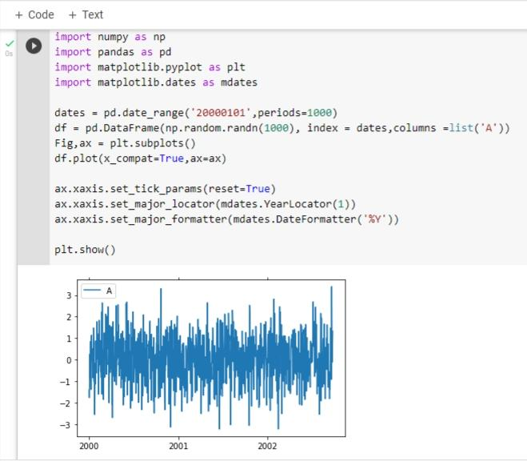The above data shows how codes as been generated by using python and a graph came out as output after running the cells, it can be seen that there are historical data for three years for number of email frequency. By generating these codes, it helped us to get a final outcome and it is quite precise data shown on the graph within 12 months of each year accounting from year 2000 to year 2002 and to be noted that it is in 2002 that the company went bankrupt due to fraud.

As written in the case study database of email went public where anyone could download it from the net which made the company bankrupt and a data schema from Enron was transferred to collab to make it in python language.

Secondly, we will analyse the bullet point

**Who are the top emailers in the organisation**

To be able to find the top emailers of the company data of employees emails and number of email sent by employees and outsiders must be analyse to sort out and find the ones with most emails sent .This can be done by using the data gathered on the question paper where python extracted data are readily available. For example the following piece of code can be used:

SELECT sender, count(mid) AS message_count

FROM message

GROUP BY sender

ORDER BY message_count;

SELECT date(date) AS date_sent, count(mid) AS message_count

FROM message

GROUP BY date_sent

ORDER BY date_sent;

It must be taken as from Monday to Sunday to get right number of email received

“Received Email Count” will defined email received in a certain period of time which will clear the way to get good outcome in the end

**Refer to script 2 file on Github for details.**

To conclude we can notice that python coding is very important and useful to solve the problem of Enron company. It helped to find hidden factors on this case. The graph also really helped in this to get accurate illustration of data in wording. It is clear that there is no need to be only report writing in words to get good information but coding and graph plotting also have its advantage when building a business report related to an issue as here it is email fraud issue. Research reveals that python is the most compatible language to understand machines, artificial science and also data science (Virginia 2020).

Reference list

# Calzon Bernardita.2021. “What Are Business Reports & Why They Are Important: Examples & Templates.” Data Pine. <https://www.datapine.com/blog/business-report-examples-and-templates/#definition>

Virginia.2020. “10 reasons why you should learn python.idtech. <https://www.idtech.com/blog/top-reasons-why-you-should-learn-python>